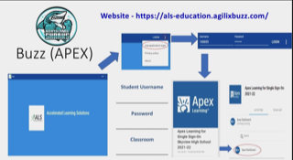

Please login in to login.readingplus.com
SITECODE: nparkhigh
Username: (North Park ID number)
Password: iimmddyy
- Intials
m- Month of birthday
d- Date of birthday
y- Year of birthday

Instagram:
@Northparkhighschool

